**Week 2-Project**

let book1={

title:"Mahabaratham",

author:"Ved vyas",

yearpublished:"1453",

readstatus:"yes",

getsummay:function(){

console.log("Hi");

},

togglereadstatus:function(){

if(this.readstatus=="yes"){

readstatus="no";

}else{

this.readstatus="yes";

}

},

}

let book2={

title:"Ramayanam",

author:"valmiki",

yearpublished:"1123",

readstatus:"no",

getsummay:function(){

console.log("Heloo");

},

togglereadstatus:function(){

if(this.readstatus=="yes"){

readstatus="no";

}else{

this.readstatus="yes";

}

}

};

let books=[];

books.push(book1);

books.push(book2);

console.log(books)

function addbook(book1){

books.push(book1);

}

addbook("Thirukural");

console.log(books)

function removelbook(){

books.pop();

}

removelbook();

console.log(books)

function addfronntbook(book2){

books.unshift(book2)

}

addfronntbook("ADD");

console.log(books);

function removefrontbook(){

books.shift();

}

removefrontbook();

console.log(books);

function getalltitle(){

let tit=val=>val.title

let out=books.map(tit)

console.log(out);

}

getalltitle();

function booksby(name){

let cusauthor=books.filter(aut=>aut.author==name)

console.log(cusauthor);

}

booksby("valmiki");

function total(year){

let getyear=books.filter(days=>days.yearpublished<year).reduce((prev,curr)=>prev+1,0);

console.log(getyear);

}

total("1453");

function removeBookByTitle(Title){

let index=books.findIndex(

function removing(){

if(books.tit==Title){

return true;

}

})

books.splice(index,1);

console.log(books);

}

removeBookByTitle("Mahabaratham");

function getBooksByReadStatus(Status)

{

let stsfil=books.filter(sts=>sts.readstatus===Status);

console.log(stsfil);

}

getBooksByReadStatus("yes");

function getSubLibrary(start, end)

{

let sublib=books.slice(start,end);

console.log(sublib);

}

getSubLibrary(1,2);

Output:

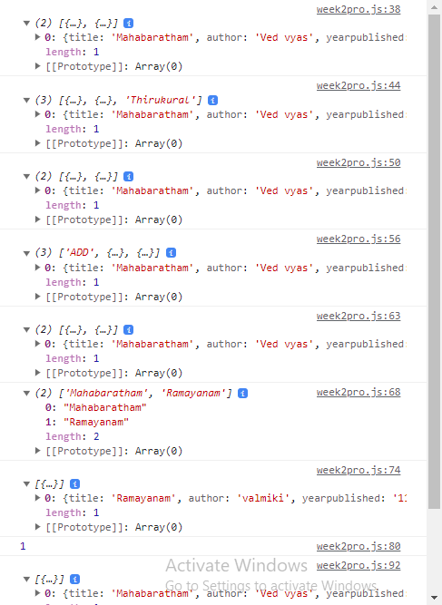

**717821E206**